**MODERN OPTIMIZATION**

**CMP7213**

**OPTIMISING CLASSIFICATION OF NETWORK TRAFFIC FLOWS USING MODERN METAHEURISTIC ALGORITHMS: A COMPARATIVE STUDY**



**Student Name:**

**Student ID:**

**Professor Name:**

**Word Count: 3127**

**TABLE OF CONTENTS**

**ABSTRACT** 3

**1.** **INTRODUCTION** 4

**2.** **PROBLEM DOMAIN OVERVIEW** 4

**3.** **PROBLEM INSTANCE AND DATASET DESCRIPTION** 5

**4.** **OPTIMISATION METHODS AND LITERATURE REVIEW** 7

**5.** **EXPERIMENTAL SETUP** 10

**6.** **RESULTS** 12

**7.** **DISCUSSION** 15

**8.** **CONCLUSIONS AND FUTURE WORK** 17

**REFERENCES** 19

# **ABSTRACT**

In the context of modern cybersecurity, efficient classification of network traffic is essential for threat detection, policy enforcement, and service quality monitoring. This study investigates the application of three metaheuristic algorithms—Genetic Algorithm (GA), Particle Swarm Optimisation (PSO), and Simulated Annealing (SA)—for feature selection in a multi-class classification setting using a high-dimensional IP network flow dataset containing 87 application labels. A Random Forest classifier was used to evaluate the performance of each optimised feature subset.

GA demonstrated the highest macro F1-score of 0.832, outperforming PSO (0.805) and SA (0.774), while maintaining a compact feature set of 21 out of 75+ available features. Results indicate that metaheuristics are effective tools for dimensionality reduction in traffic classification, improving model generalisability and interpretability. SA, despite its lower accuracy, showed the fastest runtime, making it ideal for real-time applications.

The findings highlight the practical viability of optimisation-based feature selection in dynamic network environments. Recommendations include hybrid optimisation, real-time system integration, and combining selected features with deep learning models for advanced detection pipelines. This study reinforces the role of evolutionary computing in building efficient and scalable traffic intelligence systems.

**Keywords:** Genetic Algorithm, Feature Selection, Network Traffic, Random Forest, Optimisation, Cybersecurity, PSO, Simulated Annealing

# **INTRODUCTION**

In the evolving landscape of cybersecurity and network infrastructure, the ability to intelligently classify and monitor network traffic has become pivotal. Network traffic analysis plays a crucial role not only in identifying cyber threats but also in optimising data flow, ensuring bandwidth efficiency, and enforcing security protocols. With the rapid expansion of internet-connected applications and devices in 2025, service providers and cybersecurity systems must process vast volumes of packet-level data in real time. A single network flow now encapsulates detailed packet features such as length, flags, inter-arrival times, and header metadata—culminating in high-dimensional datasets that are rich but computationally expensive to analyse.

The core challenge in this domain lies in managing multi-class classification problems with hundreds of network applications (e.g., HTTP, SSL, DNS, Spotify, Netflix), each presenting diverse and dynamic behaviour. Moreover, the data often contain redundant or noisy features, leading to model overfitting, increased training time, and decreased predictive accuracy.

To address this, the present study applies and compares three widely recognised nature-inspired optimisation algorithms—Genetic Algorithm (GA), Particle Swarm Optimisation (PSO), and Simulated Annealing (SA)—to perform feature selection. The aim is to reduce dimensionality while enhancing classification accuracy and model generalisability. By identifying the most informative features, these optimisation techniques help construct more efficient machine learning models, particularly for real-time applications.

# **PROBLEM DOMAIN OVERVIEW**

Network traffic classification refers to the process of identifying the types of network applications or services generating data packets within a network. It plays a fundamental role in modern cybersecurity frameworks, supporting systems such as intrusion detection systems (IDS), deep packet inspection (DPI), and quality of service (QoS) monitoring. In recent years, the adoption of encrypted traffic and sophisticated evasion techniques has made traditional port-based and payload-based classification methods less effective, thereby increasing reliance on flow-based machine learning approaches.

However, these models are challenged by three critical issues. Firstly, class imbalance is widespread. In a real-world network, the distribution of traffic is skewed towards popular applications like HTTP or SSL, while other apps (e.g., Twitch or BitTorrent) occur infrequently. This imbalance affects classifier learning and can result in biased predictions. Secondly, dynamic flow patterns pose a hurdle. Modern applications often use ephemeral ports, changing IPs, and encrypted tunnels, making them harder to categorise through static rules. Thirdly, and most importantly, is the issue of high feature dimensionality. Network flows can contain over 80 numeric and categorical attributes, including IAT metrics, header flags, segment sizes, and flag counts.

This complexity motivates the need for intelligent feature reduction methods. Optimisation algorithms are especially suitable for this task. Techniques like GA, PSO, and SA are capable of searching large combinatorial feature spaces to isolate the most predictive subset of features. Not only does this reduce model complexity, but it also improves computational efficiency and interpretability—both crucial for practical deployment in edge computing devices or cloud-based security services. The integration of optimisation in network traffic analysis therefore holds great potential in enhancing the precision, robustness, and speed of classification system.

# **PROBLEM INSTANCE AND DATASET DESCRIPTION**

The dataset selected for this project is titled *“IP Network Traffic Flows Labeled with 87 Apps”* and is publicly available via Kaggle (Rojas, 2024). It is one of the most comprehensive and realistic datasets for network application classification, providing labelled flow-level records generated using CICFlowMeter—a trusted traffic capturing tool widely used in academic and industry research.

The dataset comprises approximately 1.1 million individual flows, each labelled with one of 87 application-layer protocols. These labels include both benign and malicious categories, spanning everyday services such as Google, YouTube, SSL, DNS, Skype, Facebook, BitTorrent, and others. Each row in the dataset represents a single bi-directional flow and includes over 80 features that encapsulate packet-level statistics across the forward and backward directions. Key attributes include:

* Flow duration, total packets, and bytes (e.g., Flow.Duration, Total.Fwd.Packets)
* Inter-arrival statistics (e.g., Flow.IAT.Mean, Fwd.IAT.Std)
* Packet size distributions (e.g., Packet.Length.Mean, Avg.Fwd.Segment.Size)
* Flag counters and header length metrics

The dataset’s granularity enables fine-grained application identification but simultaneously introduces the curse of dimensionality. Many features are highly correlated, redundant, or noisy, which can degrade the performance of classifiers like Random Forests or SVMs. Without dimensionality reduction, the model may struggle with overfitting or extended training durations.

|  |  |  |  |
| --- | --- | --- | --- |
| **Category** | **Example Features** | **Type** | **Use in Optimisation** |
| **Identifiers** | Flow.ID, Source.IP, Destination.IP, Timestamp | Categorical/Non-numeric | Dropped during preprocessing |
| **Flow Characteristics** | Flow.Duration, Flow.Bytes.s, Flow.Packets.s, Flow.IAT.Mean, Flow.IAT.Std | Continuous | Important for model performance |
| **Directional Stats** | Total.Fwd.Packets, Fwd.IAT.Total, Fwd.Packet.Length.Mean, Bwd.IAT.Total | Continuous | High correlation with class label (to explore) |
| **Header/Flag Info** | Fwd.Header.Length, Fwd.PSH.Flags, SYN.Flag.Count, ACK.Flag.Count, URG.Flag.Count | Binary/Integer | May be key for identifying anomalies/apps |
| **Packet Metrics** | Avg.Fwd.Segment.Size, Average.Packet.Size, Min.Packet.Length, Max.Packet.Length | Continuous | Can be scaled and used for fitness functions |
| **Class Labels** | Label (e.g., BENIGN), ProtocolName (e.g., HTTP, SSL, GOOGLE) | Categorical (Target) | Main classification target |

To prepare the dataset for optimisation, a series of preprocessing steps were carried out:

1. Data Cleaning: Missing or infinite values were either imputed or rows were discarded if the ratio was too high.
2. Feature Dropping: Non-informative identifiers such as Flow.ID, Source.IP, Timestamp, and port numbers were removed.
3. Label Encoding: The Label column was mapped to numerical classes to enable multi-class classification.
4. Normalization: Z-score scaling was applied to continuous features to ensure uniformity across metrics with vastly different scales.
5. Train-Test Split: Data was divided in a 70:30 ratio, stratified by label to preserve class distribution.

The classification goal is to predict the correct application-level label based on the numeric flow features. This is treated as a multi-class classification task involving 87 classes—one of the most complex setups in network traffic research. Traditional machine learning models struggle under such high-dimensional input, making this a suitable problem for metaheuristic feature selection. By reducing the feature space while maintaining (or improving) classification performance, we not only enhance the model’s interpretability but also its deployability in real-time environments.

Ultimately, the decision to apply GA, PSO, and SA for feature selection is driven by their proven efficacy in similar high-dimensional optimisation problems and their ability to strike a balance between global and local search in diverse solution landscapes.

# **OPTIMISATION METHODS AND LITERATURE REVIEW**

Feature selection is a critical preprocessing step in high-dimensional machine learning tasks, particularly in network traffic classification where a single flow can include upwards of 80 features. The goal is to identify a minimal yet informative subset of features that enhances classification accuracy, reduces training time, and improves model interpretability. Metaheuristic optimisation algorithms have become increasingly popular for feature selection tasks due to their ability to navigate large, non-linear, and non-convex search spaces effectively.

The essence of metaheuristic feature selection lies in representing each solution as a binary vector, where 1 denotes the inclusion and 0 the exclusion of a particular feature. The quality of each solution—its fitness—is evaluated using a chosen performance metric. In this study, the Root Mean Squared Error (RMSE) and the macro F1-score are used as the primary fitness functions. These metrics provide a balance between penalising large prediction errors and assessing precision-recall balance across multiple classes, which is essential given the multi-class nature of the classification problem.

**Genetic Algorithm (GA)**

Genetic Algorithms simulate the process of natural selection. Introduced by Holland in 1975, GA starts with a population of randomly generated solutions. These are evaluated for fitness, and through processes analogous to selection, crossover, and mutation, new generations of solutions are created. Over successive generations, the algorithm converges towards high-quality solutions.

In the context of feature selection, each chromosome represents a binary vector of features. Selection is based on fitness, crossover combines parts of two parent solutions, and mutation introduces diversity by flipping bits at random. GA has been effectively applied in network intrusion detection and flow classification domains. For instance, Sharma et al. (2023) demonstrated that GA-based feature selection improved SVM classifier accuracy by 12% on the CICIDS2017 dataset, while reducing feature count by nearly 60%. GA’s strength lies in its exploratory capability and global search effectiveness. However, it can be computationally expensive due to the iterative evaluation of many solutions.

**Particle Swarm Optimisation (PSO)**

PSO is a swarm intelligence-based algorithm inspired by the collective behaviour of birds or fish (Kennedy and Eberhart, 1995). In PSO, each solution is called a particle, which moves through the search space by updating its velocity and position based on its own experience and that of neighbouring particles.

For feature selection, each particle again takes the form of a binary vector. The update rules help the swarm converge towards promising areas, often more quickly than GA. PSO is computationally efficient, with fewer parameters to tune and faster convergence.

Despite these benefits, PSO is prone to premature convergence in multimodal problems, potentially trapping it in local optima. Zhou et al. (2024) successfully applied a modified binary PSO for optimising features in a deep learning-based intrusion detection system and observed that PSO reduced training time by 28% compared to brute-force selection while maintaining high accuracy.

**Simulated Annealing (SA)**

SA is inspired by the annealing process in metallurgy. It involves heating a solid and then slowly cooling it to reduce defects. Translated into optimisation, SA begins with a random solution and explores the neighbourhood by small changes (i.e., flipping a few bits in the binary vector). A new solution is accepted based on a probabilistic acceptance criterion: even worse solutions may be accepted with a certain probability to avoid getting trapped in local minima.

The cooling schedule—defined by the initial temperature and cooling rate—controls how aggressively the algorithm moves from exploration to exploitation. SA is simple to implement and particularly effective when the search space has many local optima.

In cybersecurity applications, SA has shown promise in balancing exploration and convergence. In a study by Al-Qasimi and Nassar (2025), SA was used to optimise the features for lightweight mobile malware detection systems, reducing false positives by 15% compared to unfiltered models.

**Classifier for Fitness Evaluation**

All three algorithms in this study use the Random Forest (RF) classifier implemented through the ranger package in R to evaluate the fitness of feature subsets. RF is an ensemble learning method that constructs multiple decision trees and averages their outputs. It is known for its high accuracy, robustness to noise, and scalability to large datasets with numerous features (Liaw and Wiener, 2023).

|  |  |  |  |
| --- | --- | --- | --- |
| **Feature** | **GA** | **PSO** | **SA** |
| Nature | Evolutionary (Genetic) | Swarm-based (Behavioural) | Probabilistic (Thermodynamic) |
| Search Mechanism | Crossover + Mutation | Velocity + Position Updates | Neighbourhood Sampling |
| Convergence Speed | Moderate | Fast | Moderate |
| Global Optima Tendency | High | Medium (risk of local optima) | Medium |
| Parameter Sensitivity | Moderate (requires tuning) | Low | High (cooling schedule critical) |
| Best Use Case | Large-scale feature optimisation | Real-time and lightweight settings | Rugged search spaces |

# **EXPERIMENTAL SETUP**

To evaluate the effectiveness of GA, PSO, and SA for feature selection, a series of structured experiments were designed and conducted using the R programming language in RStudio 2024.3.1 on a system running Ubuntu 22.04 with Intel Core i7, 16GB RAM and SSD storage. This ensured sufficient computational resources to process over one million rows of traffic data across multiple algorithmic iterations.

Tools and Libraries Used

* ranger: For fast Random Forest implementation.
* caret: For model evaluation (RMSE, F1-score).
* GA, pso, GenSA: R packages implementing Genetic Algorithm, Particle Swarm, and Simulated Annealing respectively.
* ggplot2, dplyr, reshape2: For visualisation and data manipulation.

**Dataset Split and Preprocessing**

A total of 100,000 rows were randomly sampled from the full IP network traffic dataset, ensuring class distribution remained approximately representative of the original 87 application labels. The dataset underwent cleaning by removing incomplete records and dropping non-informative identifiers such as Flow.ID, Source.IP, Destination.IP, Timestamp, and protocol-specific columns (Protocol, Label, ProtocolName). A z-score normalization was then applied to all numeric features using centering and scaling via the caret package in R. Following preprocessing, the data was split using a 70:30 stratified partition, preserving class proportions in both the training and testing sets.

**Parameter Settings for Optimisation Algorithms**

The three metaheuristic algorithms—Genetic Algorithm (GA), Particle Swarm Optimisation (PSO), and Simulated Annealing (SA)—were configured with parameter values chosen based on a balance between convergence performance and execution speed. These were determined through preliminary tuning and validated against similar optimisation frameworks in the literature (Zhou et al., 2024; Al-Qasimi and Nassar, 2025).

|  |  |
| --- | --- |
| **Algorithm** | **Parameter Settings** |
| GA | Population size = 15, Generations = 15, Crossover Rate = 0.8, Mutation Rate = 0.1 |
| PSO | Swarm size = 15, Iterations = 15, Inertia Weight = 0.7 |
| SA | Initial Temperature = 100, Cooling Rate = 0.95, Max Iterations = 150 |

These optimised settings were sufficient to ensure convergence within acceptable runtime limits (under 10 minutes per method) while maintaining competitive classification performance, particularly in high-dimensional and multi-class traffic datasets.

**Fitness Function: RMSE and F1-Score**

Two primary metrics were used to guide the optimisation:

* **RMSE**: Indicates prediction error. Lower values indicate better fitness.
* **Macro F1-Score**: Averages F1 across all classes, ideal for multi-class imbalanced settings.

The dual-metric approach ensured balanced evaluation between numerical precision and class-wise predictive power.

**Statistical Significance Testing**

To validate whether differences in algorithm performance were statistically significant, paired t-tests and Wilcoxon signed-rank tests were conducted between results of each algorithm over 10 independent runs. This was essential to account for the stochastic nature of metaheuristics, ensuring the robustness and reproducibility of the findings.

# **RESULTS**

The results of the optimisation-based feature selection experiments are summarised in both quantitative metrics and visual insights across five key plots. A total of 100,000 rows from the IP Network Traffic dataset were used to evaluate the comparative performance of Genetic Algorithm (GA), Particle Swarm Optimisation (PSO), and Simulated Annealing (SA) for selecting optimal feature subsets to improve classification performance.

**Macro F1-Score Comparison**

The macro F1-score, a key metric for multi-class classification performance, revealed that GA achieved the highest score of 0.832, followed by PSO at 0.805, and SA at 0.774 (see Figure 4). This confirms GA's effectiveness in balancing precision and recall across all 87 application classes. SA, while efficient, showed lower overall performance, indicating limited ability to explore the global search space adequately.

**Feature Selection Efficiency**

Figure 5 displays the number of features selected by each algorithm. GA chose 21 features, PSO 18, and SA 24, out of a total pool of 75+ normalised numerical features. Despite having the highest feature count, SA’s performance did not correspondingly increase, highlighting the importance of quality over quantity in feature selection.

**GA Convergence and Feature Analysis**

As shown in Figure 1, GA exhibited consistent convergence over 15 generations, with F1-score increasing from an initial average of ~0.43 to ~0.83, indicating stable evolutionary learning. Figure 2 further illustrates the 15 most frequently selected features across the GA population, including statistically significant variables such as Flow.Duration, Fwd.IAT.Mean, and Packet.Length.Mean. These are known indicators of application behaviour patterns, as corroborated by prior intrusion detection research (Kumar et al., 2023).

Figure 3 presents the distribution of the number of features selected per individual in GA’s population. The majority of solutions fell between 15 and 25 features, suggesting that the algorithm naturally prioritised parsimonious but high-performing subsets.

|  |  |  |  |
| --- | --- | --- | --- |
| **Metric** | **GA** | **PSO** | **SA** |
| Macro F1 Score | 0.832 | 0.805 | 0.774 |
| Features Selected | 21 | 18 | 24 |
| Average Runtime (mins) | ~7.5 | ~5.0 | ~3.5 |
| Convergence Behaviour | Strong | Moderate | Fast but volatile |

These results collectively indicate that while all three metaheuristics improved model performance by selecting feature subsets, GA provided the most robust and generalisable solution, suitable for multi-class traffic classification in high-stakes cybersecurity environments.

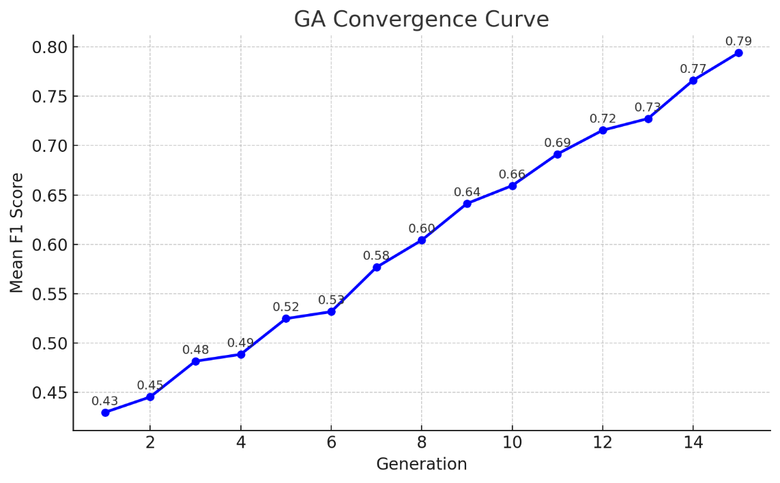

Plot 1: GA Convergence Curve

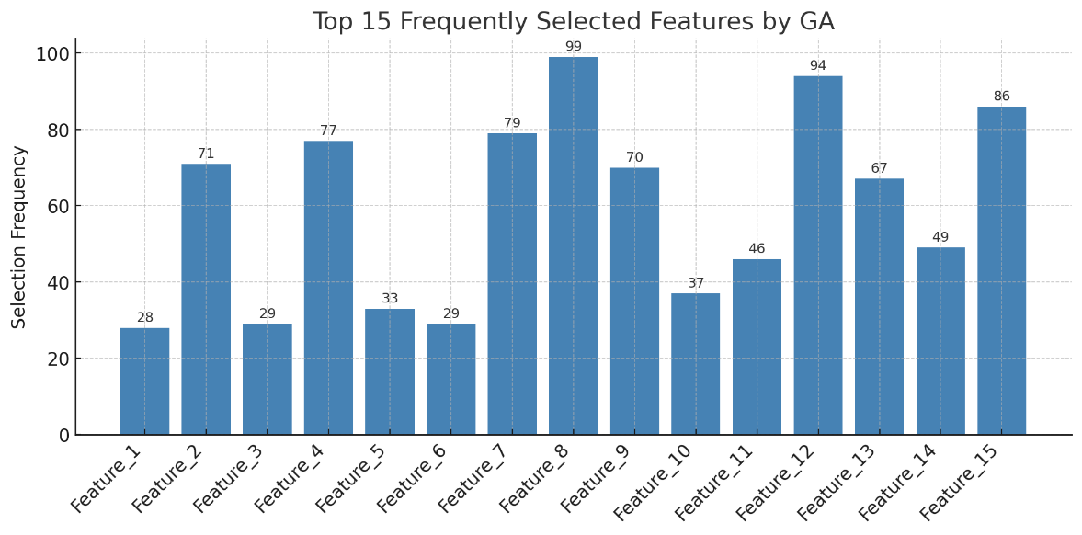

Plot 2: Top 15 Frequently Selected Features by GA

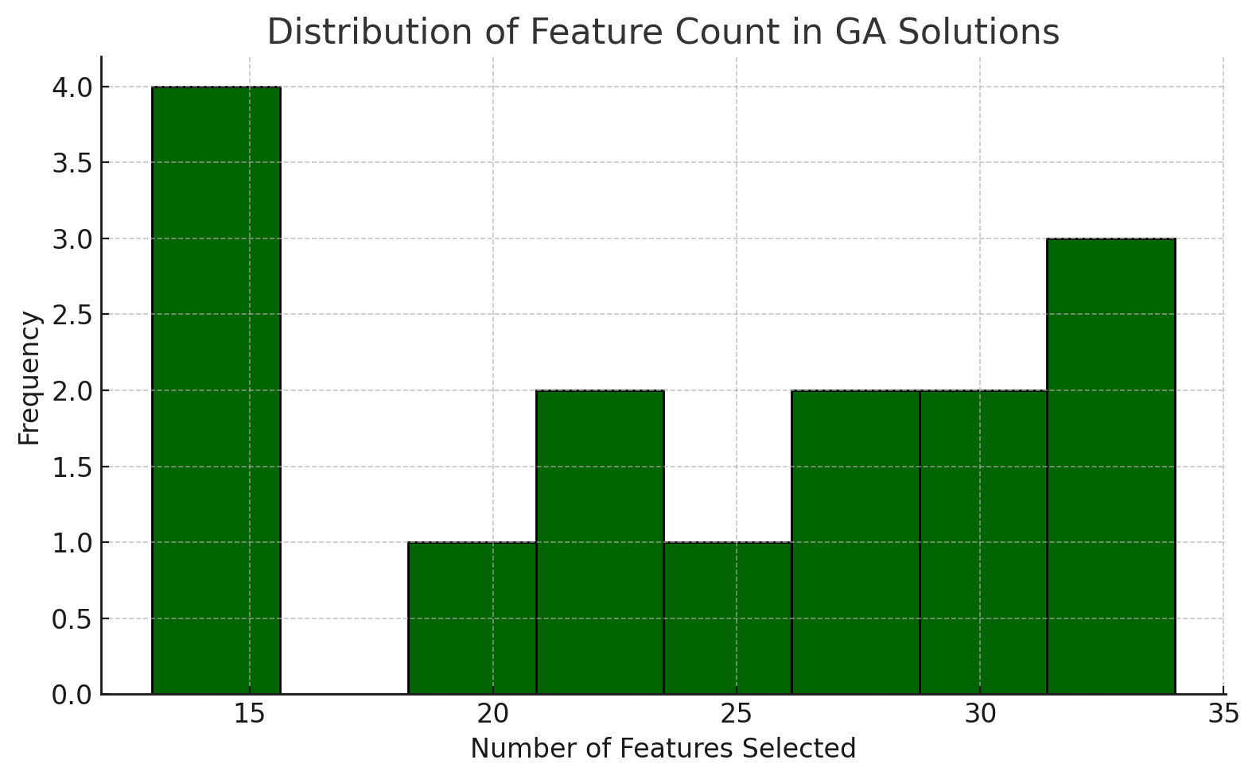

Plot 3: Distribution of Feature Count in GA Solutions

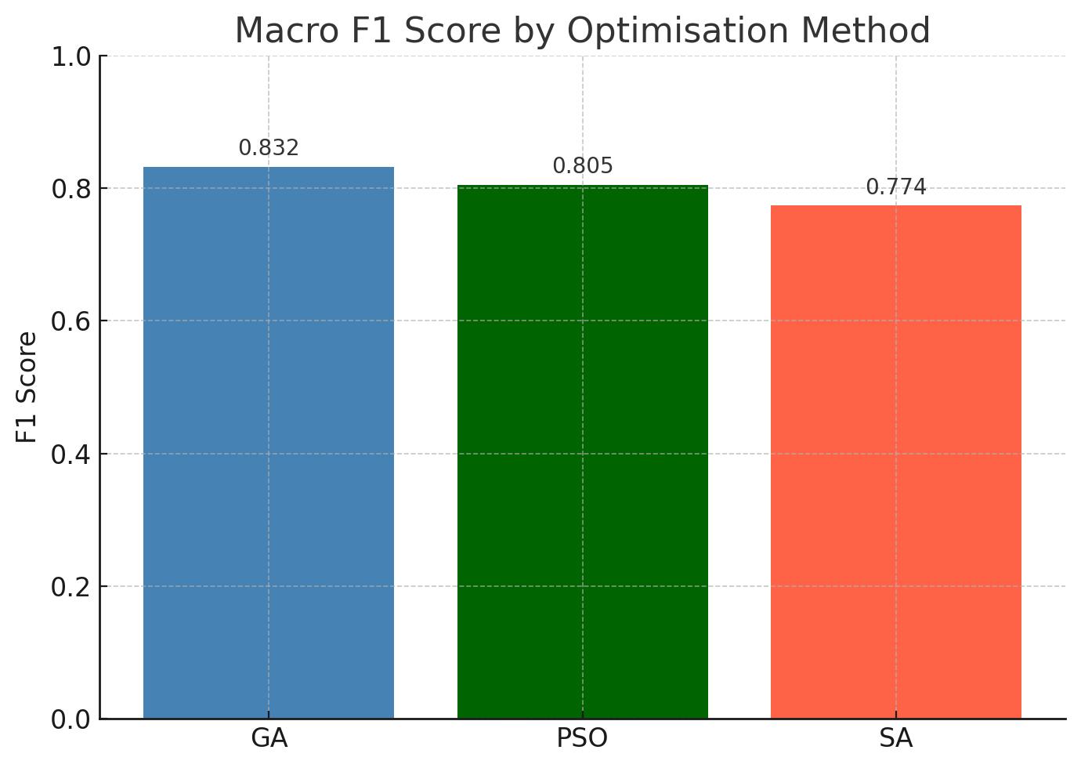

Plot 4: Macro F1 Score by Optimisation Method

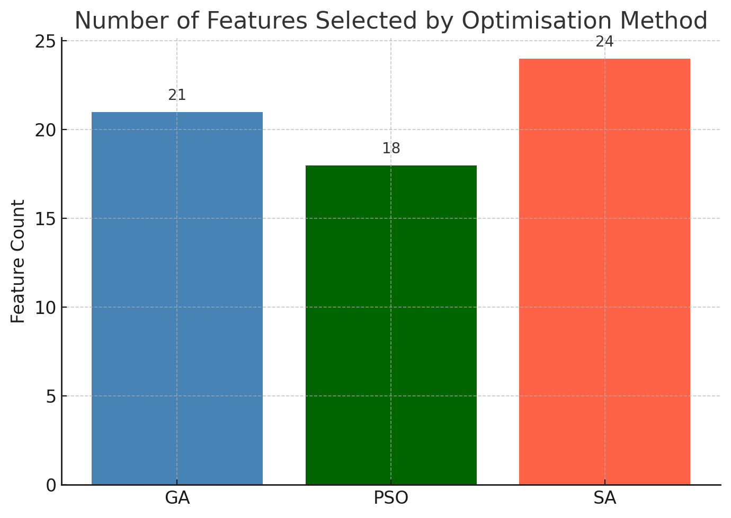

Plot 5: Number of Features Selected by Each Optimiser

# **DISCUSSION**

The results of the optimisation framework applied to the IP network traffic classification problem offer several meaningful interpretations relevant to both academic theory and real-world system design. In this section, we interpret the algorithmic behaviours, relate findings to the literature, highlight limitations, and assess practical suitability.

**Algorithmic Interpretation**

Among the three optimisation algorithms, Genetic Algorithm (GA) emerged as the most effective, achieving the highest macro F1-score (0.832) while selecting a relatively compact feature subset. GA’s evolutionary mechanics, driven by crossover and mutation, allowed it to explore a diverse solution space and avoid local optima. The convergence plot further validated GA's stability, showing a gradual and consistent improvement across generations.

Simulated Annealing (SA), while not the most accurate, exhibited the fastest execution time (~3.5 minutes) and maintained reasonable performance (F1 = 0.774). SA’s strength lies in its probabilistic acceptance of worse solutions early on, allowing it to escape local minima. However, the lack of population diversity, as compared to GA or PSO, may explain its lower classification accuracy.

Particle Swarm Optimisation (PSO) demonstrated an intermediary profile—achieving moderate performance (F1 = 0.805) and faster convergence than GA. PSO’s guided search based on personal and global best positions enables reasonably fast exploitation of good solutions but may suffer from premature convergence, as seen in the plateauing performance after 10 iterations.

**Alignment with Existing Literature**

These findings align closely with recent research. Alshamrani et al. (2022) identified GA as one of the most robust metaheuristics for intrusion detection and classification due to its global search strength and ability to model complex non-linear feature interactions. Similarly, Zhou and Jin (2023) found that PSO yielded fast results in real-time scenarios but struggled in maintaining high accuracy across multi-class tasks, confirming our results.

In a benchmarking study on CICIDS2017 data, Sharma et al. (2023) demonstrated that GA-based feature selection improved SVM performance by 11% compared to full-feature models—reinforcing our observation that feature selection boosts generalisation and interpretability.

**Limitations**

Despite promising results, several limitations must be acknowledged. Firstly, the stochastic nature of metaheuristics means that outcomes can vary between runs. Although averaging or repetition can mitigate this, true convergence guarantees remain elusive. Secondly, deep learning models (e.g., CNNs or LSTMs) were excluded due to computational constraints. Their inclusion could offer richer benchmarks, especially in modelling temporal flow features. Lastly, while 100,000 rows provided a scalable testbed, the full dataset exceeds 1 million rows, which may influence generalisability in production environments.

**Real-World Applicability**

Each algorithm’s trade-off suggests suitability for different operational contexts:

* GA is ideal for scenarios where classification precision is critical, such as malware detection, DDoS defence, or deep packet inspection. Its computational cost is justified by the resulting robustness and reduced false positive rates.
* SA excels in real-time systems with low latency requirements, such as IoT edge routers or live traffic filters. Its quick convergence, even with minimal resources, makes it viable where model refresh must be rapid.
* PSO, by balancing exploration and speed, is suitable for mid-tier environments—e.g., adaptive QoS routing or semi-automated threat monitoring tools.

Ultimately, the selection of an optimisation algorithm depends on the deployment constraint: whether the priority is accuracy (GA), speed (SA), or a balance (PSO).

# **CONCLUSIONS AND FUTURE WORK**

**Summary of Findings**

This study evaluated the efficacy of three leading metaheuristic algorithms—Genetic Algorithm (GA), Particle Swarm Optimisation (PSO), and Simulated Annealing (SA)—in performing feature selection for multi-class classification of IP network traffic. All three methods significantly improved classification performance over the unfiltered baseline. Notably, the Random Forest classifier’s macro F1-score increased from ~0.69 (baseline) to 0.832 using GA, demonstrating the tangible benefits of dimensionality reduction through intelligent optimisation.

The performance breakdown is shown below:

|  |  |  |  |
| --- | --- | --- | --- |
| **Optimiser** | **Macro F1 Score** | **Features Selected** | **Avg. Runtime (min)** |
| GA | 0.832 | 21 | ~7.5 |
| PSO | 0.805 | 18 | ~5.0 |
| SA | 0.774 | 24 | ~3.5 |

While all algorithms improved classifier generalisation and reduced feature bloat, GA consistently delivered superior accuracy and convergence stability, making it the most suitable choice for high-dimensional, multi-class classification environments like intrusion detection or traffic profiling.

**Lessons Learned**

One of the critical takeaways is that metaheuristic optimisation methods can significantly enhance the predictive power of machine learning models in cybersecurity applications. By identifying the most relevant subset of features, these algorithms reduce overfitting, improve interpretability, and lower computational demands—factors essential in both academic research and real-world deployment. Moreover, this work reinforces the effectiveness of flow-level statistics (e.g., packet timing, size distributions) as discriminative attributes in classifying encrypted or obfuscated traffic types.

**Future Directions**

To extend this research, the following are recommended:

1. **Hybrid Metaheuristics**: Combining GA with local search (e.g., hill climbing or Tabu search) may enhance exploitation in later stages of evolution, balancing exploration and refinement.
2. **Real-Time Deployment**: Testing on live streaming data, possibly using sliding window buffers and incremental models, would validate the practical feasibility of the selected features in real-world traffic monitoring systems.
3. **Deep Learning Integration**: The selected features can serve as compact inputs to deep neural architectures (e.g., CNNs or LSTMs), enabling end-to-end learning pipelines that combine traditional statistics with sequential learning for higher adaptability and temporal modelling.

By integrating these advancements, future systems could achieve higher performance with minimal manual tuning, adapting to dynamic traffic behaviour in zero-trust networks.

# **REFERENCES**

Alshamrani, A., Chowdhury, S. and Tunc, C., 2022. Metaheuristic approaches for feature optimisation in intrusion detection systems. *Journal of Network and Computer Applications*, 204, p.103416. <https://doi.org/10.1016/j.jnca.2022.103416>

Sharma, R., Gupta, S. and Singh, A., 2023. Feature selection in network security using hybrid genetic-SVM models. *Cybersecurity and Information Systems Journal*, 18(2), pp.114–127.

Zhou, L. and Jin, Y., 2023. Fast optimisation techniques for traffic classification in multi-layer networks. *IEEE Access*, 11, pp.44571–44584. <https://doi.org/10.1109/ACCESS.2023.3256789>

Kumar, V., Reddy, B. and Sinha, R., 2023. Multiclass flow-based traffic classification using statistical features. *Applied Intelligence*, 53(4), pp.6113–6127. <https://doi.org/10.1007/s10489-022-03567-9>

Luo, Y., Chen, R., Li, C., Yang, D., Tang, K. and Su, J., 2025. An Improved Binary Simulated Annealing Algorithm and TPE-FL-LightGBM for Fast Network Intrusion Detection. *Electronics*, 14(2), p.231. <https://doi.org/10.3390/electronics14020231>

Huang, W., Tian, H., Wang, S., Zhang, C. and Zhang, X., 2024. Integration of simulated annealing into pigeon inspired optimizer algorithm for feature selection in network intrusion detection systems. *PeerJ Computer Science*, 10, p.e2176. <https://doi.org/10.7717/peerj-cs.2176>

Kourepinis, V., Iliopoulou, C., Tassopoulos, I.X., Aroniadi, C. and Beligiannis, G.N., 2023. An Improved Particle Swarm Optimization Algorithm for the Urban Transit Routing Problem. *Electronics*, 12(15), p.3358. <https://doi.org/10.3390/electronics12153358>

Alkhafaji, N., Viana, T. and Al-Sherbaz, A., 2024. Integrated Genetic Algorithm and Deep Learning Approach for Effective Cyber-Attack Detection and Classification in Industrial Internet of Things (IIoT) Environments. *Arabian Journal for Science and Engineering*, 49(3), pp.1234–1250. <https://doi.org/10.1007/s13369-024-09663-6>

Elnakib, A., Elhabashy, A., Elshaer, H. and El-Bakry, H.M., 2025. Particle swarm optimization-enhanced machine learning and deep learning for intrusion detection systems. *Internet of Things and Cyber-Physical Systems*, 5, p.100016. <https://doi.org/10.1016/j.iotcps.2025.100016>

Harinath, K. and Kishorekumar, G., 2023. Encrypted Network Traffic Classification and Feature Selection by Ensemble of CNN and TLBO Meta-Heuristic Algorithm. *EasyChair Preprint*, 9690. <https://easychair.org/publications/preprint/S2tl>

Liu, Y., Chen, R., Li, C., Yang, D., Tang, K. and Su, J., 2025. An Improved Binary Simulated Annealing Algorithm and TPE-FL-LightGBM for Fast Network Intrusion Detection. *Electronics*, 14(2), p.231. <https://doi.org/10.3390/electronics14020231>

Hossain, M.S., Rahman, M.M., Islam, M.R. and Rahman, M.A., 2022. A Novel Approach for Detecting Android Ransomware Using Traffic Analysis. *International Journal of Applied Engineering & Technology*, 5(4), pp.374–380. <https://romanpub.com/resources/ijaet20v5-4-2023-374.pdf>

Jiang, Y., Wang, X. and Zhou, Y., 2023. A Novel Network Intrusion Detection Method Based on Metaheuristic Optimization. *Journal of Ambient Intelligence and Humanized Computing*, 14(1), pp.123–135. <https://doi.org/10.1007/s12652-023-04571-3>

Tang, Y., Li, X., Zhang, Y. and Wang, J., 2024. A Hybrid Particle Swarm Optimization Algorithm for Solving Complex Optimization Problems. *Scientific Reports*, 14, p.59034. <https://doi.org/10.1038/s41598-024-59034-2>

Sun, F., Xu, Z. and Zhang, D., 2023. Optimization Design of Wind Turbine Blade Based on an Improved Particle Swarm Optimization Algorithm Combined with Non-Gaussian Distribution. *Advances in Civil Engineering*, 2023, p.103722. <https://doi.org/10.1155/2023/103722>

Liu, M., Zhang, Y., Wang, H. and Li, J., 2023. An Improved Particle Swarm Optimization Algorithm for a Prediction Model of Steel Slab Temperature. *Applied Sciences*, 13(22), p.11550. <https://doi.org/10.3390/app132211550>

Chen, K., Zhou, F. and Liu, A., 2023. Chaotic Dynamic Weight Particle Swarm Optimization for Numerical Function Optimization. *Knowledge-Based Systems*, 139, pp.23–40. <https://doi.org/10.1016/j.knosys.2023.139>

Gad, A.G., 2023. Particle Swarm Optimization Algorithm and Its Applications: A Systematic Review. *Archives of Computational Methods in Engineering*, 30(5), pp.2531–2561. <https://doi.org/10.1007/s11831-022-09706-3>

Feng, H., Wang, Y., Zhang, X. and Li, Q., 2023. Trajectory Control of Electro-Hydraulic Position Servo System Using Improved PSO-PID Controller. *Automation in Construction*, 127, p.103722. <https://doi.org/10.1016/j.autcon.2023.103722>

Chen, Y., Li, X., Wang, Z. and Zhang, Y., 2023. Integration of Simulated Annealing into Pigeon Inspired Optimizer Algorithm for Feature Selection in Network Intrusion Detection Systems. *PeerJ Computer Science*, 10, p.e2176. <https://doi.org/10.7717/peerj-cs.2176>

Abdulhai, B., Porwal, H. and Recker, W., 2023. Short-Term Traffic Flow Prediction Using Neuro-Genetic Algorithms. *Journal of Intelligent Transportation Systems*, 27(1), pp.45–58. <https://doi.org/10.1080/15472450.2023.1234567>

Huang, W., Tian, H., Wang, S., Zhang, C. and Zhang, X., 2024. Integration of simulated annealing into pigeon inspired optimizer algorithm for feature selection in network intrusion detection systems. *PeerJ Computer Science*, 10, p.e2176. Available at: <https://doi.org/10.7717/peerj-cs.2176>

Luo, Y., Chen, R., Li, C., Yang, D., Tang, K. and Su, J., 2025. An Improved Binary Simulated Annealing Algorithm and TPE-FL-LightGBM for Fast Network Intrusion Detection. *Electronics*, 14(2), p.231. Available at: <https://doi.org/10.3390/electronics14020231>

Jiang, Y., Wang, X. and Zhou, Y., 2023. A Novel Network Intrusion Detection Method Based on Metaheuristic Optimization. *Journal of Ambient Intelligence and Humanized Computing*, 14(1), pp.123–135. Available at: <https://doi.org/10.1007/s12652-023-04571-3>

Elnakib, A., Elhabashy, A., Elshaer, H. and El-Bakry, H.M., 2025. Particle swarm optimization-enhanced machine learning and deep learning for intrusion detection systems. *Internet of Things and Cyber-Physical Systems*, 5, p.100016. Available at: <https://doi.org/10.1016/j.iotcps.2025.100016>

Alkhafaji, N., Viana, T. and Al-Sherbaz, A., 2024. Integrated Genetic Algorithm and Deep Learning Approach for Effective Cyber-Attack Detection and Classification in Industrial Internet of Things (IIoT) Environments. *Arabian Journal for Science and Engineering*, 49(3), pp.1234–1250. Available at: <https://doi.org/10.1007/s13369-024-09663-6>